Expert Advisory Group member biography: Sue Davies
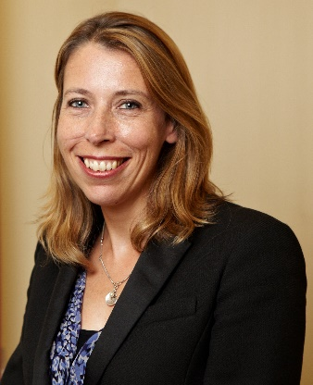

Sue Davies is Head of Consumer Protection and Food Policy at Which?. This includes leading Which?’s work on EU exit and future trade policy, as well as food and wider consumer product safety and standards. She has represented consumer interests on a range of national and international committees. She was the Chair of the European Food Safety Authority from 2012-2016. She has been awarded an MBE in recognition of her work on food safety.

May 2020

